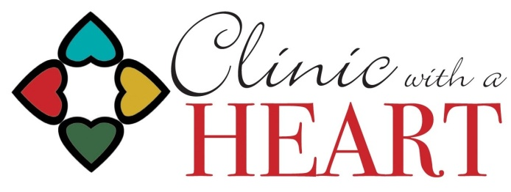

Dental Provider Application for Clinic with a Heart

Name:

Business Address:

Hometown: ________________________________________________________________________________________

Email Address:

Primary Phone:

License Type:

Birthday (MM/DD):

Emergency Contact:
Name Phone Number

VOLUNTEER STATEMENT: I am 19 years of age or older, and I wish to donate my services to Clinic with a Heart as a Medical Provider through the Volunteer Services Program. I understand that there is no payment or billing for services rendered under the Volunteer Program of Clinic with a Heart. I also understand that photographs may be taken from time to time for publication or other uses. I agree to abide by the rules, policies, and procedures of Clinic with a Heart.

I agree to inform Clinic with a Heart Administration of any pending disciplinary action, pending legal action or instituted legal action, investigation regarding privilege/credentialing status or licensure, and/or any change of status with any of the information provided on this application.

I understand that a current Nebraska license is required (license type specified above).

I understand Clinic with a Heart’s Professional Liability Insurance does not include coverage for licensed physicians and dentists while practicing at Clinic with a Heart. I further understand that physicians, dentists, and chiropractors will be required to have in effect current individual Professional Liability Insurance that covers their practice at Clinic with a Heart. Additionally, I understand that physician assistants, APRNs, pharmacists, mental health provider, and physical therapists with active licenses are covered by Clinic with a Heart’s Professional Liability Insurance when practicing at Clinic with a Heart.

To the best of my knowledge, I am able to perform all assigned duties at Clinic with a Heart.

Please check all that apply:
- I have Professional Liability Insurance that would be active while practicing at Clinic with a Heart.
- I do not currently have Professional Liability Insurance that would be active at Clinic with a Heart.

In addition to the attestations above, my signature on this form also provides my agreement to the Release of Liability attached.

Dated this_________ day of ______________________, 20____

Signature of Applicant___________________________________________
VOLUNTEER ACKNOWLEDGEMENT
AND RELEASE AGREEMENT

In consideration of the participation of the undersigned (the “Team Member”), an individual who is at least 19 years of age, in or with Clinic with a Heart, Inc., a Nebraska nonprofit corporation (the "Clinic”), the receipt and sufficiency of which is expressly acknowledged, Team Member understands, warrants and agrees as follows (the “Agreement”):

1. Release of Liability.

Team Member acknowledges and agrees that:

- Health care, in any form and especially involving donated services in free clinic settings can be an inherently dangerous activity, carrying the significant risk of serious personal injury or death;
- The conditions and risks are frequently beyond the control of the Clinic, and the Clinic is not able to completely mitigate such risks to the Team Member; and
- Team Member shall, at all times be responsible for, and shall be required to exercise all reasonable care for his/her own safety.

Except to the extent covered by the Clinic’s Blanket Accident Insurance policy, Team Member, for him/her self, spouse, successor, and heirs, does hereby release, waive, absolve, discharge and agree to hold harmless the Clinic, including other Team Members and the Clinic’s representatives, officers, directors, employees, agents, affiliates, insurers and attorneys (collectively, the "Released Parties"), from and against any and all rights, claims, demands, causes of action, obligations, suits, liens, damages or liabilities of any kind and character whatsoever, whether known or unknown, suspected or claimed, which Team Member shall or may have in the future against the Released Parties arising out of, based on, related to or connected with Team Member's participation in any Clinic related activities.

2. Personal Responsibility.

Team Member agrees that upon becoming a volunteer with the Clinic, he/she WILL:

- Adhere to the Policy and Procedures of Clinic with a Heart. Stay informed about Clinic operations, events, and changes by accepting and reading the monthly electronic newsletter and communication memos from the Clinic;
- Participate in relevant educational offerings;
- Record volunteer work time in and out and position worked;
- Know his/her team/discipline assignment and his/her team/discipline leader and how to contact him/her;
- Utilize his/her team/discipline sign up scheduling system in advance of the clinic/meeting, and if unable to fill a work commitment, notify the team/discipline leader in advance;
- Learn and perform the duties of his/her position and seek assistance if needed;
- Treat patients, guests, and other volunteers with dignity and respect;
- Share concerns or ideas for improvement with a team leader or Clinic staff;
- Participate in the welcoming and orientation of new Clinic volunteers;

3. Additional Terms.

Team Member acknowledges that the Agreement is executed in exchange for the opportunity to participate in the Clinic and the Clinic related activities. This Agreement shall remain in force until written revocation thereof is delivered to the Clinic, however, Team Member recognizes that such revocation will result in Team Member being prohibited from further participation in the Clinic and the Clinic related activities. The Clinic reserves the right to terminate Team Member’s participation in the Clinic and Clinic related activities at any time in its sole discretion with or without notice.

Team Member has read the Agreement in its entirety, understands it, voluntarily agrees to it, and further understands that Team Member has given up substantial rights by signing it. The person(s) signing this document has full authority and capacity to do so. If any portion of this Agreement is found to be invalid, the remainder shall continue in full force and effect. This Agreement shall be binding upon the Team Member and his/her respective heirs, personal and legal representatives, and successors.

Dated _____________________________________, 20_____

Signature: ______________________________________________

